1.Find out if the given number is an Armstrong number. Logic-if 153 is the supplied value, then 13 + 53 +33 = 1+125+27 = 153 .This is the same as supplied value hence it is an Armstrong number.

**Solution:**

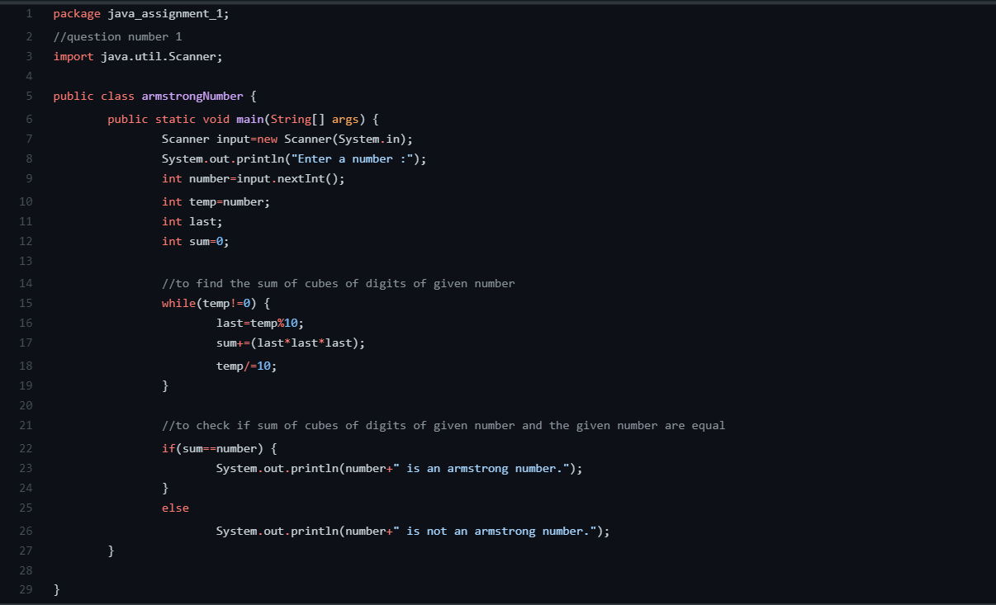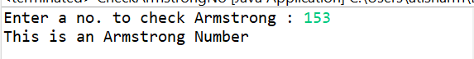

2. Find out all the Armstrong no. between the range 100 – 999.

**Solution:-**

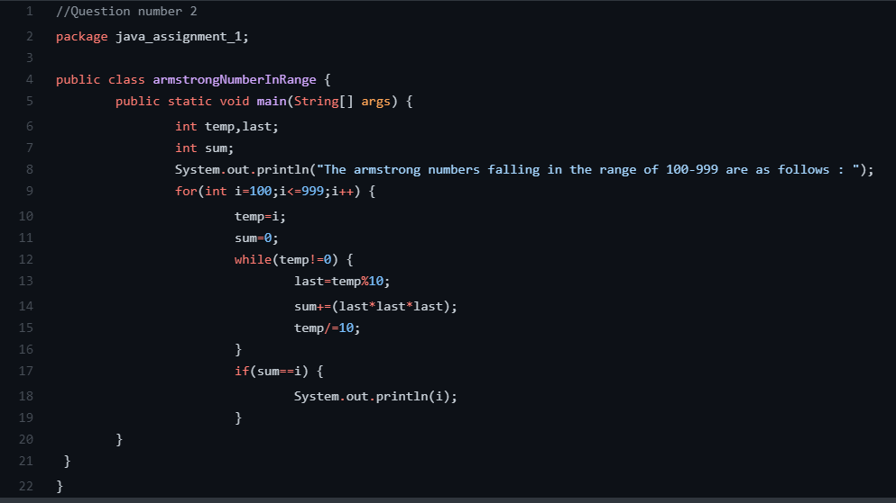

**Output:**



3. Find the Simple as well as the compound interest of supplied value.

Solution:

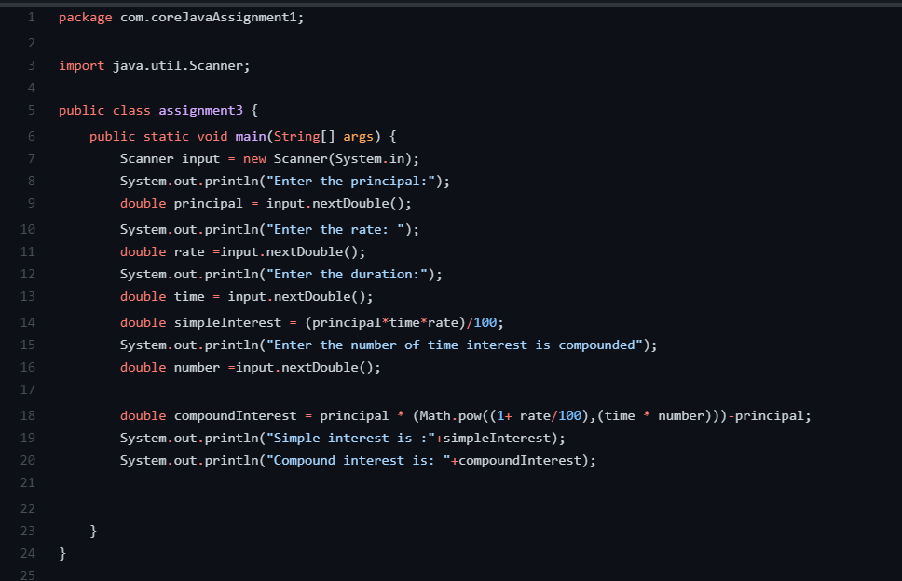

4. Supply marks of three subject and declare the result, result declaration is based on below conditions:

Condition 1: -All subjects marks is greater than 60 is Passed

Condition 2: -Any two subjects marks are greater than 60 is Promoted

Condition 3: -Any one subject mark is greater than 60 or all subjects' marks less than 60 is failed.

**Solution:-**

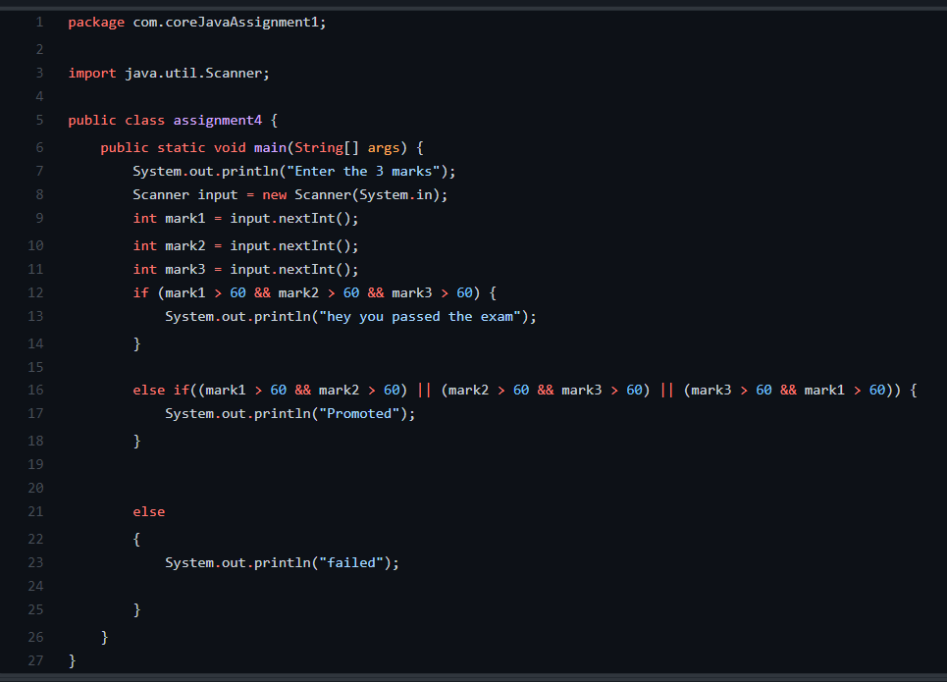

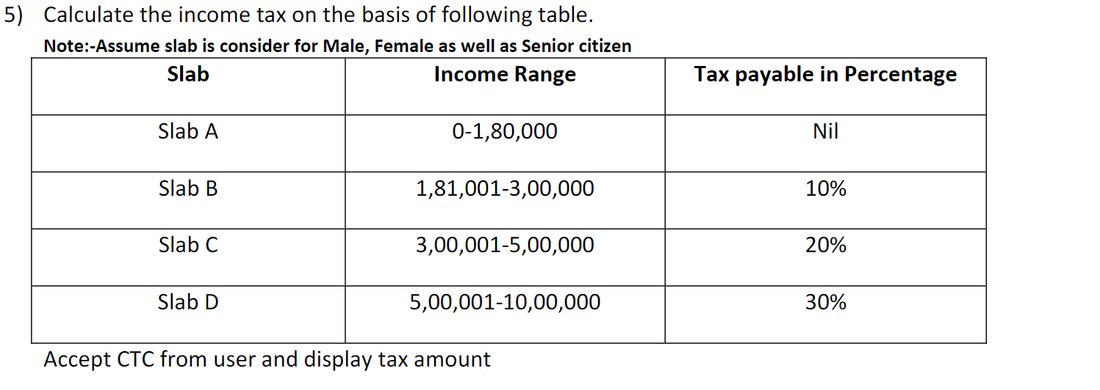

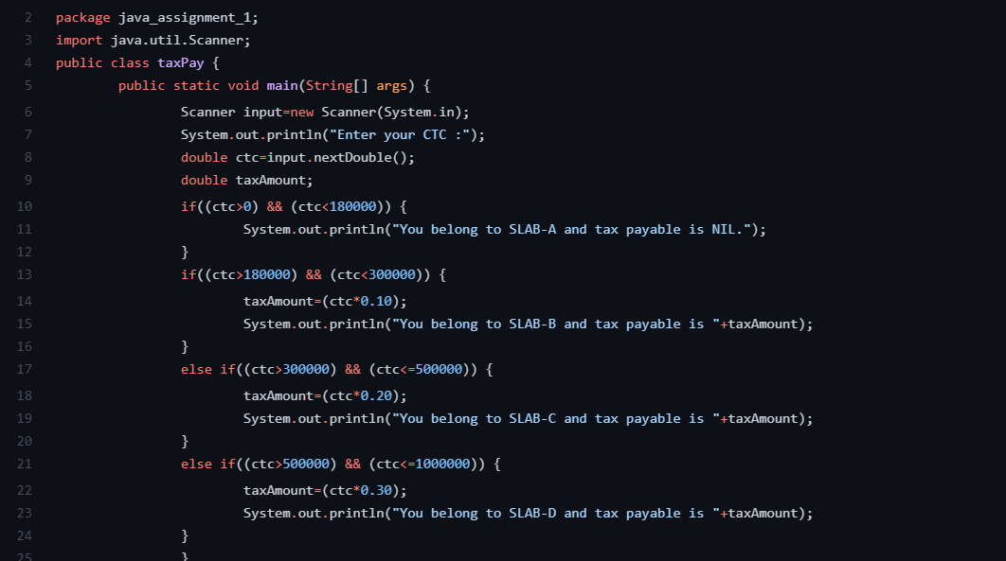

**6.**Consider a CUI based application, where you are asking a user to enter his Login name and password, after

entering the valid user-id and password it will print the message “Welcome” along with user name. As per the

validation is concerned, the program should keep a track of login attempts. After three attempts a message

should be flashed saying “Contact Admin" and the program should terminate.

**Solution:-**

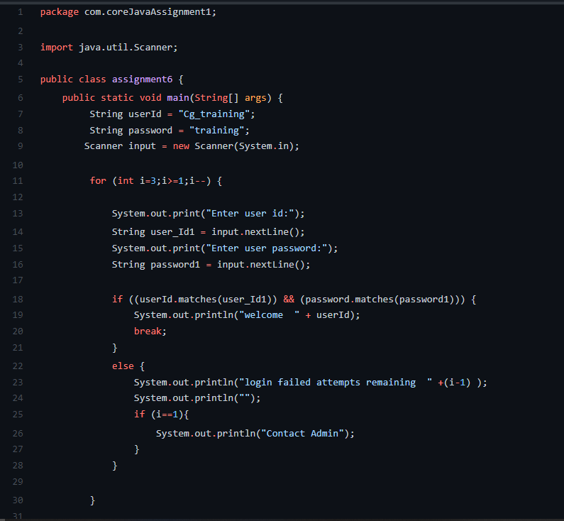

7. There is an Array which is of the size 15, which may or may not be sorted. You should write a program to accept a number and search if it in contained in the array.

